Design and Implementation of a Low-Cost, Modular Universal Testing Machine for Small-Scale Material Characterization
Abstract
The rapid expansion of advanced materials science research and additive manufacturing technologies has made testing the mechanical properties of polymeric materials a necessity for laboratories. However, the high costs of traditional Universal Testing Machines (UTMs) severely restrict access to this equipment for small-scale laboratories and independent researchers. In line with the principle of the "democratization of science," this study presents the design, production, and validation of an open-source, low-cost tensile testing device designed entirely from scratch. The developed system consists of a 300 kg capacity load cell, a NEMA 17 stepper motor with a 50:1 reducer, custom components produced via 3D printing, and a control architecture based on the Arduino Mega 2560. To prevent electronic signal noise frequently encountered in microcontroller-based systems, a special 3D-printed Faraday cage was designed for the HX711 analog-to-digital converter module. Due to the device's compact structure, performance validation tests were conducted using PLA filament pieces 120 mm in length and 1.75 mm in diameter instead of standard ASTM D638 test specimens. Real-time stress-strain data were obtained through a developed Python-based user interface. Manual displacement validations performed with a digital caliper showed an error margin of approximately 2% resulting from mechanical backlash in the trapezoidal lead screw system. The findings prove that the designed system is a cost-effective, transparent, and reliable alternative for small-scale material characterization. All hardware and software files belonging to the study have been made available to researchers as open access.
Keywords: Democratization of science, Open-source hardware, Universal testing machine, Tensile testing, Additive manufacturing, Signal noise optimization.
1. Introduction
Accurate characterization of the mechanical behavior of engineering materials forms the basis of reliable structural designs and optimization processes. Particularly, the spread of additive manufacturing processes at industrial and academic levels has created a need for rapid and continuous testing of produced thermoplastic and composite prototypes. Universal Testing Machines are considered the standard for determining fundamental properties such as stress, compression, and elasticity modulus. However, these industrial-quality devices involve extremely high investment and maintenance costs. Furthermore, the closed-source software architectures used by these systems prevent researchers from intervening in test parameters or modifying the system according to their specific needs. These economic and structural constraints create a hardware bottleneck that is difficult to overcome, especially for budget-constrained educational institutions, small-scale research laboratories, and independent developers.
Developments in the rapidly growing Open Source Hardware (OSHW) movement and desktop 3D printing technologies in recent years have enabled traditional laboratory equipment to be produced directly in the laboratory environment at much lower costs. This transformation is referred to in academic literature as the "democratization of science". The democratization of science means that research capacity ceases to be a privilege of institutions with massive budgets and is offered to the access of every researcher producing knowledge globally through open-source designs. 3D printer technology has been the driving force of this democratization process by enabling the local, low-cost, and highly customizable production of complex mechanical parts. The development of affordable and open-source testing hardware is not just an economic preference today, but a scientific necessity supporting global equality of opportunity.
When the literature is examined, various open-source testing machine prototypes designed using 3D printed parts and microcontrollers are encountered. However, the majority of these systems fail to reach the high sampling rates required to produce data of academic publication quality or encounter excessive signal noise problems caused by low-budget electronic components. In existing low-cost systems, fluctuations experienced during the conversion of analog signals from the load cell to digital compromise the reliability of the obtained stress-strain graphs.
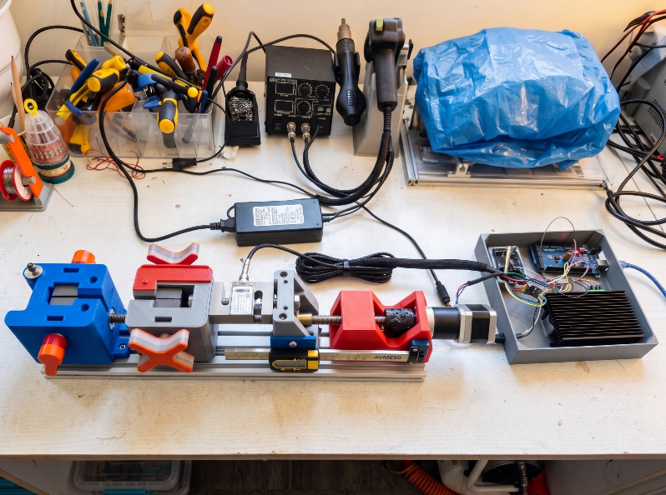
This study presents a modular tensile testing device designed from scratch with high data collection stability to address these deficiencies in the current literature. The electronic architecture of the developed device is shaped around the Arduino Mega 2560 microcontroller, and the HX711 module is integrated into a special 3D-printed Faraday cage to maximize analog signal quality. High torque transmission is provided by a stepper motor with a 50:1 ratio planetary gearbox.
Figure 1. Low-cost and modular tensile testing device set up in a laboratory environment.
In accordance with the principle of academic integrity, the capacity limitations of the developed device are clearly defined. The desktop dimensions and targeted low-cost structure of the system naturally limit the tensile force capacity. Therefore, the system was designed and validated for testing standard polymer filament samples 120 mm long and 1.75 mm in diameter, rather than standard ASTM D638 plastic tensile specimens that require high force. Additionally, due to structural constraints arising from unavoidable mechanical backlash in the trapezoidal lead screw and nut mechanism, manual caliper validations determined that the system contains an error margin of approximately 2% in displacement measurements. Despite all these limitations, the device succeeded in offering real-time data analysis by working seamlessly integrated with a Python interface we wrote. To fully comply with the philosophy of the democratization of science, all software codes, electronic circuit diagrams, and 3D CAD models belonging to the study have been shared openly for researchers via the GitHub platform (or OSF - Open Science Framework).
2. Design and Methodology
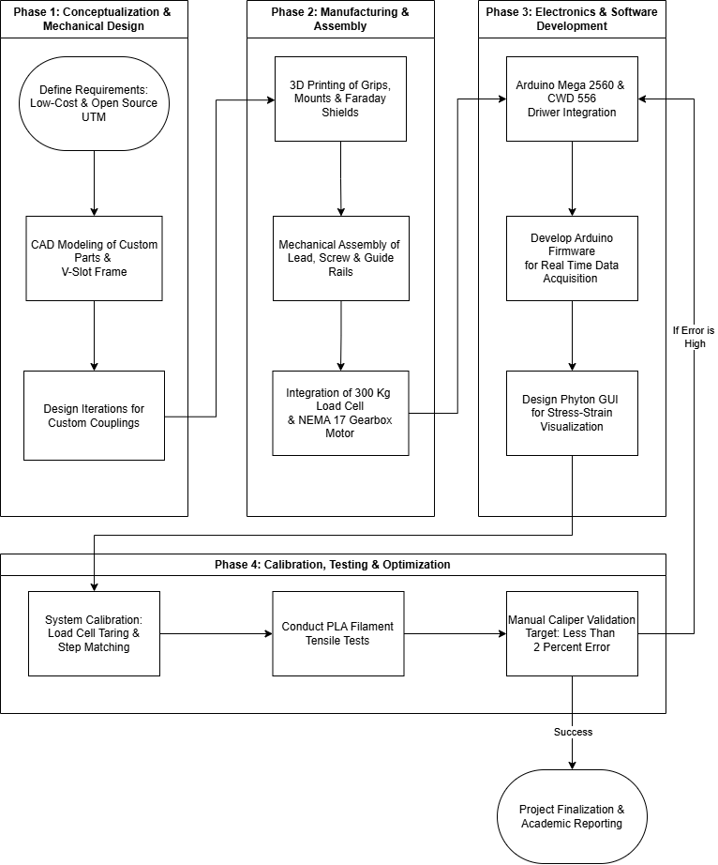
The developed tensile testing device consists of three fundamental subsystems: the mechanical chassis, the electronic signal processing unit, and the data collection software. The modular structure of the device is optimized to provide rapid adaptation to different test scenarios and sample types. All development and design processes of the system from the idea stage to the final reporting are summarized in Figure 2.

Figure 2. Project Development Workflow
2.1. Mechanical Design and Power Train
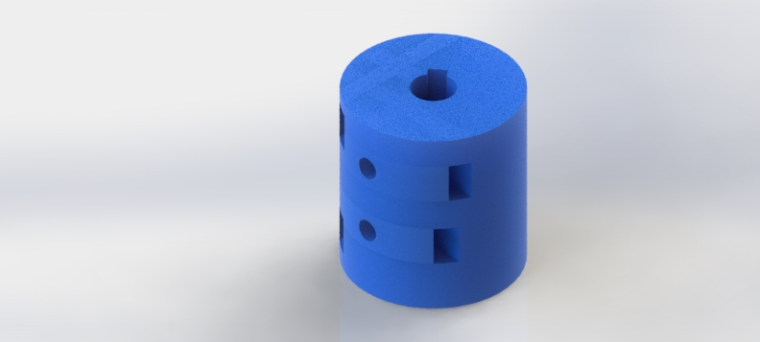
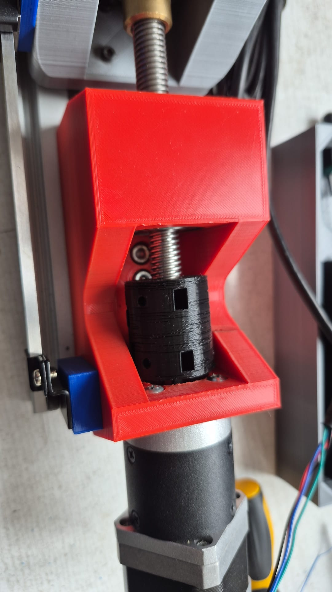
The main chassis of the system was constructed using V-Slot aluminum extrusion profiles to minimize deflection under axial loads and ensure high rigidity. The movable crosshead on the chassis moves on linear guides and receives its drive from a trapezoidal lead screw mechanism. A stepper motor with a 50:1 ratio high-precision planetary gearbox was used in the drive unit of the system to meet the high torque at low speed requirement sought in standard testing devices. The transfer of high-torque rotational motion from the motor shaft to the trapezoidal lead screw is of critical importance for system dynamics. To tolerate axial misalignments that may occur during this transfer and prevent torque loss, 3D-printed couplings specially designed for the system's dynamic loads were used instead of standard market couplings. These couplings, designed in the SolidWorks environment, reached optimum strength and fatigue life in their fourth version as a result of endurance tests and successive iterations. The specimen holder jaws were similarly produced with a 3D printer and possess a special V-groove geometry to clamp 1.75 mm diameter cylindrical filament samples without slipping.
Figure 3. Custom 3D-Printed Coupling: From Design to Application
2.2. Electronic Architecture and Signal Isolation
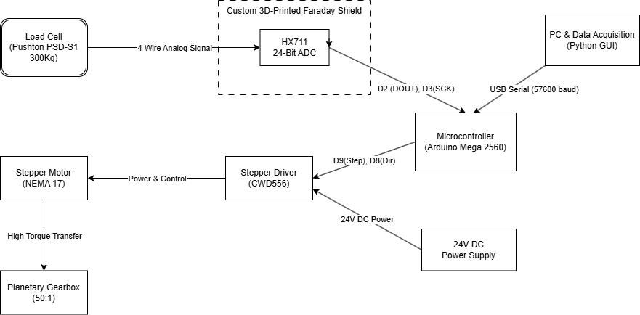
The electronic control of the system is provided by an Arduino Mega 2560 microcontroller that establishes two-way serial communication with the computer at a baud rate of 57600. A high-precision load cell with a 300 kg capacity (Pushton PSD-S1) was used to measure the tensile force. The conversion of analog signals from the load cell to digital is performed with the HX711 24-bit ADC (Analog-to-Digital Converter) amplifier. The biggest problem encountered in open-source and low-cost electronic systems is that electromagnetic interference from motor drivers and environmental factors causes fluctuations (noise) in sensor readings at the millivolt (mV) level. In this project, a special 3D-printed Faraday cage housing covered with conductive insulation tape was designed to eliminate signal noise on the ADC module. This isolation strategy is one of the most important innovations bringing data accuracy closer to industrial standards. The driving of the propulsion system is controlled by an industrial-grade CWD556 stepper motor driver with high current capacity.
Figure 4. Simplified electronic system architecture of the developed universal testing machine
2.3. Software Architecture and Kinematic Resolution
The user interface and data collection software were developed with the Python programming language in accordance with the open-source philosophy. Utilizing the power of Pandas and NumPy libraries, this interface reads raw force and position data from the microcontroller at 100-millisecond intervals and converts them into real-time stress-strain graphs. Mechanical displacement (elongation) data is calculated via software directly through the kinematic equations of the drive system without using an external linear encoder. The theoretical mechanical resolution of the system is expressed by Equation 1:
$$Resulition= \frac{Screw Pitch}{Motorstep x Microstep Ratio x Reducer Ratio}$$
Thanks to the microstepping settings adjusted via the CWD556 driver and the 50:1 planetary gear reduction, the number of steps per millimeter was calibrated to 20,000. This indicates that the theoretical positioning resolution of the system is at the $5 x {10}^{-5}$ mm level. However, structural gaps (backlash) between the trapezoidal lead screw and the nut cause this theoretical resolution to deviate slightly in practice. When the applied force (F) and position data reach the system, the software calculates instantaneous stress ($σ$) and strain ($ε$) values according to standard engineering formulas in Equation 2 and Equation 3:
$σ$ = $\frac{F}{A_{0}}$
$ε$ = $\frac{∆L}{L_{0}}$
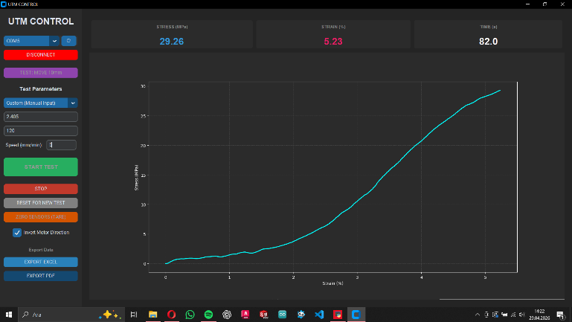
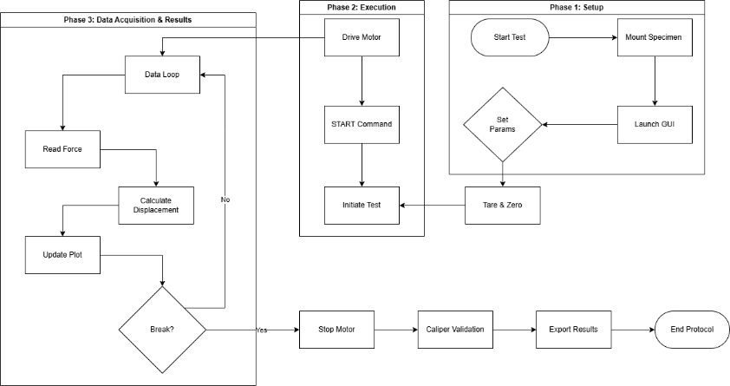
Here, $A_{0}$ represents the initial cross-sectional area of the sample, $L_{0}$ the initial length, and $∆L$ the amount of displacement. At the end of the test, the interface has the capability to export all obtained data in Excel (CSV) format for detailed analysis and graphical PDF reports.
Figure 5. Python-based data collection interface and real-time operational workflow cycle.
3. EXPERIMENTS, CALIBRATION, AND FINDINGS
A series of calibration procedures and material rupture experiments were carried out to prove the validity of the system's theoretical design in practical application. The tests were structured to determine the stability, data resolution, and error margins of the device.
3.1. Sensor Calibration and Validation
For an accurate stress-strain analysis, it is mandatory to calibrate both the load cell and the kinematic displacement calculations. In the first stage, standard reference weights were used for the calibration of the 300 kg capacity Pushton load cell, and tare operations were standardized by optimizing the calibration factor of the HX711 module via software. Thanks to the 3D-printed Faraday cage used for signal isolation, sensor fluctuations in the idle state were reduced to $\pm 0.05$ N levels. In the second stage, the validation of the theoretical elongation amount (strain) calculated from the stepper motor steps was performed. In open-loop stepper motor systems, differences can occur between the theoretical and actual position due to tolerances in mechanical transmission organs. To measure this deviation, manual displacement validation was performed using a high-precision digital caliper during the movement of the crosshead. When the elongation values read from the software and the physical displacement values read from the caliper were compared, it was determined that the system had an error margin of approximately 2%. As a result of mechanical analyses, it was determined that the fundamental source of this 2% error margin is the axial gaps (backlash) between the trapezoidal lead screw and nut mechanism. This error margin brought about by the use of cost-effective trapezoidal screws instead of expensive ball screw systems used in traditional industrial devices is within acceptable limits for the education and small-scale R&D activities targeted by the device.
BURAYA GÖRSEL GELECEK: Kumpas ile yapılan manuel doğrulama anını gösteren fotoğraf.
Figure 6. In-situ displacement validation and backlash analysis performed using a digital caliper.
3.2. PLA Filament Tensile Tests and Findings
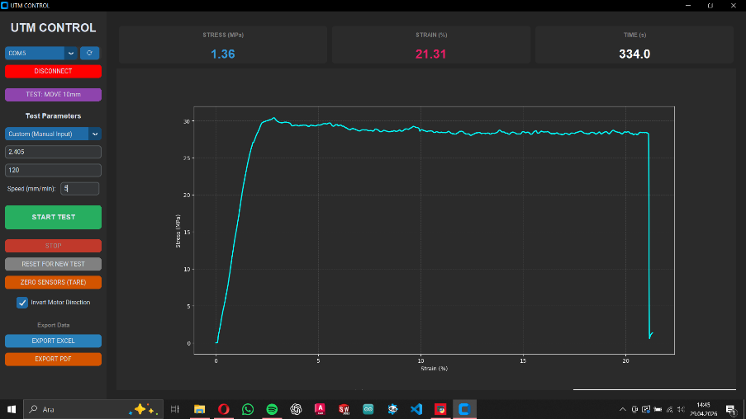
To evaluate the test performance of the device, tensile tests were applied to Polylactic Acid (PLA) material, which is widely used in additive manufacturing. In line with the capacity constraints stated in Section 1, cylindrical PLA filaments with a 120 mm gauge length and 1.75 mm standard diameter were used as test specimens. The tests were started at a constant tensile speed determined via the Python-based user interface. Load and position data were collected at 100 ms intervals throughout the entire process from the sample's transition from the elastic region to the plastic deformation region until the moment of final fracture. Thanks to the integrated data processing algorithm of the interface, the characteristic Stress-Strain graph belonging to the filament sample was plotted simultaneously. When the obtained graphs are examined, it is clearly seen that the linear elastic region, yield strength, and Ultimate Tensile Strength (UTS) points of the PLA material are compatible with PLA characteristics in the academic literature. Following the completion of the test, the software successfully ended the reporting process by automatically exporting the raw data and the generated graph in Excel and PDF formats.

Figure 7. Stress-strain curve obtained as a result of the tensile test applied to a 1.75 mm diameter PLA filament sample.
4. DISCUSSION AND CONCLUSION
In this study, the design, production, and calibration of a cost-effective, modular, and high-precision Universal Testing Machine (UTM) for small-scale material characterization were successfully carried out. The most important output of the study is the proof that the basic mechanical testing capabilities offered by industrial systems costing tens of thousands of dollars can be obtained with a much more accessible budget using open-source hardware and 3D printing technologies. The combination of Arduino Mega 2560 and the 3D-printed Faraday cage used in the electronic infrastructure of the system successfully isolated analog signal noise, the biggest handicap of microcontroller-based devices, and increased data quality. Although a 2% mechanical backlash error resulting from the use of a low-cost trapezoidal screw was detected, this does not compromise the reliability of the device for the targeted usage scenarios. The PLA filament rupture tests performed showed that the developed Python interface has the capability of simultaneous data collection and graphing at industrial standards. In future studies, it is planned to integrate an optical or magnetic linear encoder into the system to completely eliminate the 2% error margin in the current system. Additionally, adding anti-backlash nut designs to the chassis to hardware-prevent mechanical gaps will further increase the precision of the system. Consequently, this project, which contributes directly to the goal of the democratization of science, offers a strong open-source reference model for researchers and educational institutions with limited budgets to produce their own laboratory equipment.

